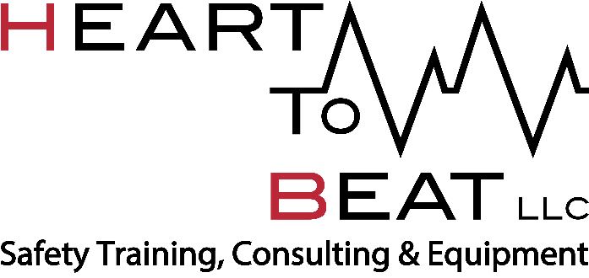
Job Title:
Emergency Medical Response (EMR) Instructor
Reports To:
The Instructor will report to the CEO.
Classification:
Non-Exempt
Job Overview:
A part-time position with Heart To Beat (HTB) , EMR Instructors report to the CEO. EMR Instructors are responsible for the learning of all students in his/her class. The EMR Instructors are expected to teach the American Heart Association (AHA), American Safety and Health Institute (ASHI) CPR and EMR courses at various locations contracted by HTB. EMR courses are scheduled for three weekdays in a row, for two weeks back-to-back. Therefore, the Instructor must be able to commit to six (6) full teaching days over a two-week period. It’s expected that there will be 8-12 EMR courses per year. Some of these courses will be at client locations throughout the country, requiring periodic travel for 3-4 nights at a time. Other EMR courses are taught at the HTB main office in Baltimore County, MD. Commitment is required from Instructors at the time that courses are contracted.
Responsibilities and Duties – Out of Town Classes
- Assures preparation for EMR class materials, including presentations, handouts, and tests.
- Serves as the main point of contact for the client throughout training classes.
- Arranges for travel needs with HTB’s office assistant.
- Travels to the client location, arriving in sufficient time for daily class set-up
- Meets with client at time of service.
- Teaches ASHI required curriculum in a timely, consistent, and highly proficient matter
- Administers quizzes as required, grades, and provides student feedback accordingly.
- Issues and collects all required paperwork in accordance with HTB procedures and files accordingly.
- Issues various certification cards as required, following all company policies and procedures.
- Finalizes completion of each six-day certification course with the client prior to leaving at the end of training.

Responsibilities and Duties – In- Town Classes
- Assures preparation for EMR class materials, including presentations, equipment, handouts, and tests.
- Serves as the main point of contact for the client throughout training classes.
- Conducts courses from HTB’s Baltimore County Training Center.
- Arrives in sufficient time to set-up for classes on all teaching days.
- Teaches ASHI required curriculum in a timely, consistent, and highly proficient matter
- Administers quizzes as required, grades, and provides student feedback accordingly.
- Disinfects and ensures equipment is serviceable following class each day.
- Issues and collects all required paperwork in accordance with HTB procedures and files accordingly.
- Issues various certification cards as required, following all company policies and procedures.
- Finalizes completion of each six-day certification course with the client.

Qualifications:
- High School Diploma or greater.
- Must currently possess or obtain American Heart Association (AHA), American Safety and Health Institute (ASHI) Emergency Medical Response, and Stop the Bleed Instructor level certifications within the first 60 days of employment.
- Emergency Medical Technician (EMT) or Paramedic qualifications preferred.
- Ability to speak confidently and conduct EMR courses as a lead instructor.
- Ability to lift 30 or more pounds independently.
- Must be enthusiastic, responsible, articulate and well organized.
- Must have flexibility in various work environments, and be willing to travel locally and to client locations out-of state. Periodic, multi-night travel is required.
- Valid Driver’s License and clean driving record.
- Successful completion of Pre-Employment Screening background check.

Physical Demands

The physical demands described here are representative of those that must be met by an employee to successfully perform the essential functions of this job.

While performing the duties of this job, the employee is regularly required to talk and hear. This position is very active and requires standing, walking, bending, kneeling, stooping and crouching. The position may require occasional lifting of products weighing up to 30 pounds.

Position Type and Expected Hours of Work

This is a part-time position and regularly requires long hours and frequent evening and weekend work.

Travel

Must have flexibility in various work environments and be willing to travel locally.
Work Authorization/Security Clearance
All employees must complete I-9 authorization within first three days of employment.
AAP/EEO Statement
Heart To Beat is an equal opportunity employer. All applicants will be considered for employment without attention to race, color, sex, religion, sexual orientation, veteran status, national origin, age, disability, or any other protected classification.

Other Duties

Please note this job description is not designed to cover or contain a comprehensive listing of activities, duties or responsibilities that are required of the employee for this job. Duties, responsibilities and activities may change at any time with or without notice.

Signatures
This job description has been approved by all levels of management:
Manager_______________________________________________

Employee signature below constitutes employee's understanding of the requirements, essential functions and duties of the position.
Employee______________________________​ Date_____________

